CNC LATHE
PROGRAMMING & MACHINING
CASE MANUAL
Case drawings, programming logic, representative G-code, cycle interpretation and shop-floor review notes.
G71 / G70 | G72 / G73 | G74 / G75 | G76 / G92
G02 / G03 | G96 / G97 | C-Axis | Live Tooling

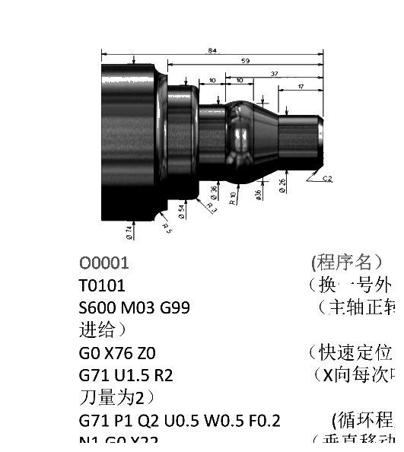 | 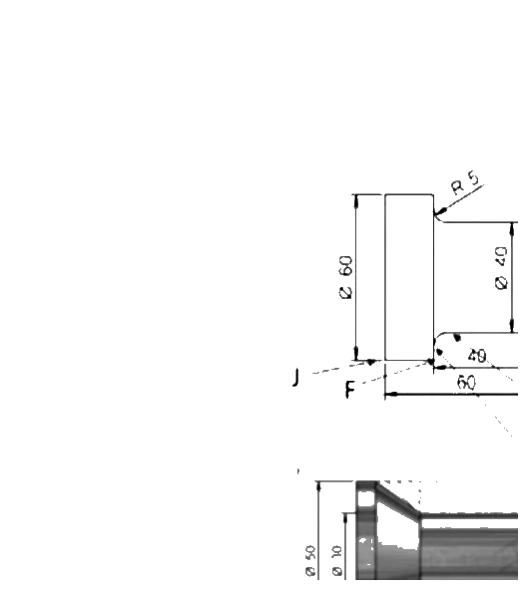 | 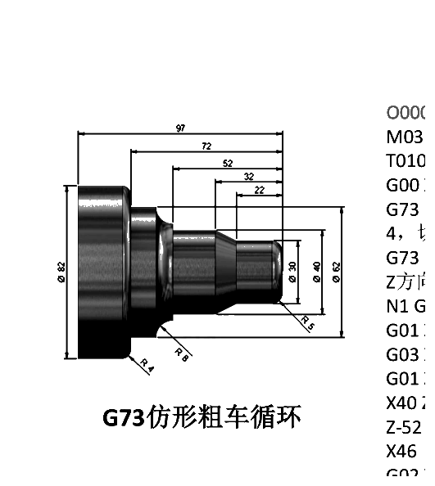

How to Use This Manual
Each case follows a compact structure: source drawing, machining objective, representative program, program logic and practical review points. The source programs are teaching examples; controller syntax, M-codes, offsets, compensation and safe positions must be validated on the actual machine.
Core Cycle Reference
• G71 - longitudinal rough turning
• G70 - finishing a P/Q contour
• G72 - facing roughing
• G73 - pattern-repeating roughing
• G74 / G75 - grooving
• G76 / G92 - threading
• G96 / G97 - constant surface speed / fixed rpm
• G02 / G03 - circular interpolation

CASE 01 | G71 Arc Groove
G71 ROUGH TURNING
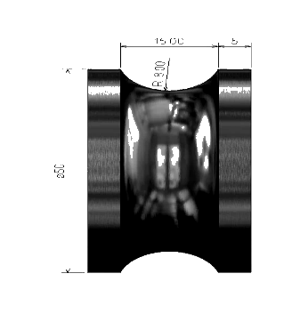 | Machining Objective  Rough a concave arc-groove contour and leave stock for finishing  Program Logic  The program uses G71 rough turning to generate the feature shown in the drawing. Review the start position, cutting direction, stock allowance, feed mode and safe retract before running the cycle.
Representative CNC Program
T0101
S600 M03
G0 X52 Z5
G71 U1.5 R2
G71 P1 Q2 U0.5 W0.5 F0.2
N1 G0 X50
G1 Z-6.5
G3 X50 Z-18.5 R6.5
N2 G1 X52
G0 X150 Z150
M30
Key Review Points
• Verify work zero, raw-stock size and chuck/jaw clearance.
• Confirm tool number, offset, insert geometry and spindle/feed mode.
• Check every rapid move and the final retract position.
• Confirm P/Q contour validity and finishing allowance on the actual controller.

CASE 02 | G92 Thread Cutting Loop
G92 THREADING
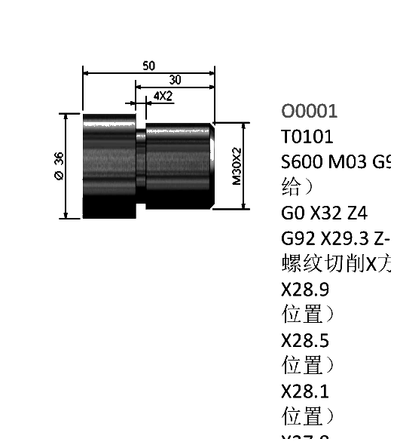 | Machining Objective  Cut an external thread through repeated G92 passes at progressively smaller X diameters  Program Logic  The program uses G92 threading to generate the feature shown in the drawing. Review the start position, cutting direction, stock allowance, feed mode and safe retract before running the cycle.
Representative CNC Program
T0101
S600 M03 G99
G0 X32 Z4
G92 X29.3 Z-28 F2
X28.9
X28.7
X28.5
X28.1
X27.8
G0 X150 Z150
M30
Key Review Points
• Verify work zero, raw-stock size and chuck/jaw clearance.
• Confirm tool number, offset, insert geometry and spindle/feed mode.
• Check every rapid move and the final retract position.
• Confirm thread pitch, final diameter, infeed depth and run-out clearance.

CASE 03 | G71 Comprehensive Profile
G71 + G70
Machining Objective
Rough a stepped multi-radius profile, change tools, then finish the same P/Q contour
Program Logic
The program uses G71 + G70 to generate the feature shown in the drawing. Review the start position, cutting direction, stock allowance, feed mode and safe retract before running the cycle.
Representative CNC Program
T0101
S600 M03 G99
G0 X76 Z0
G71 U1.5 R2
G71 P1 Q2 U0.5 W0.5 F0.2
N1 ... final contour ...
N2 X76
T0202
S1600 M03
G70 P1 Q2
M30
Key Review Points
• Verify work zero, raw-stock size and chuck/jaw clearance.
• Confirm tool number, offset, insert geometry and spindle/feed mode.
• Check every rapid move and the final retract position.
• Confirm P/Q contour validity and finishing allowance on the actual controller.

CASE 04 | G71 Stepped Profile
G71 CONTOUR ROUGHING
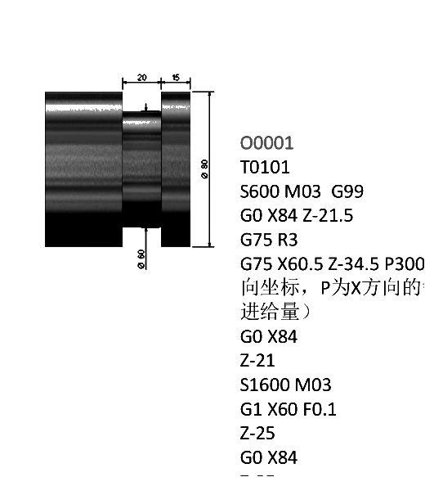 | Machining Objective  Apply G71 to a multi-diameter external profile with shoulders and a radius transition  Program Logic  The program uses G71 contour roughing to generate the feature shown in the drawing. Review the start position, cutting direction, stock allowance, feed mode and safe retract before running the cycle.
Representative CNC Program
T0101
S600 M03
G0 X76 Z0
G71 U1.5 R2
G71 P1 Q2 U0.5 W0.5 F0.2
N1 G0 X20
G1 ...
G3 ... R10
N2 X76
G0 X150 Z150
M30
Key Review Points
• Verify work zero, raw-stock size and chuck/jaw clearance.
• Confirm tool number, offset, insert geometry and spindle/feed mode.
• Check every rapid move and the final retract position.
• Confirm P/Q contour validity and finishing allowance on the actual controller.

CASE 05 | U-Shaped Groove
G71 / G70
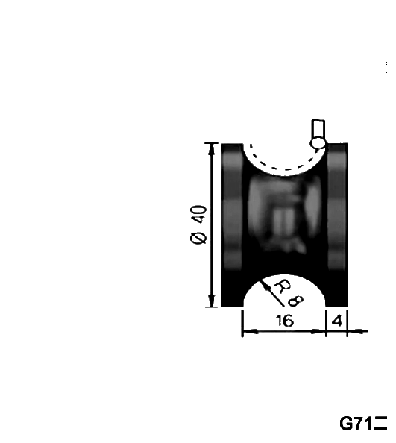 | Machining Objective  Machine a U-shaped groove by embedding an arc in the P/Q contour  Program Logic  The program uses G71 / G70 to generate the feature shown in the drawing. Review the start position, cutting direction, stock allowance, feed mode and safe retract before running the cycle.
Representative CNC Program
T0101
M03 S800
G0 X43.5 Z-5.5
G71 U1 R0.5 F0.2
G71 P1 Q2 U0.5 W0
N1 G0 X43 W0
G1 X40 Z-5.5 F0.15
G2 X40 Z-18.5 R6.5
N2 G1 X43
G70 P1 Q2
M30
Key Review Points
• Verify work zero, raw-stock size and chuck/jaw clearance.
• Confirm tool number, offset, insert geometry and spindle/feed mode.
• Check every rapid move and the final retract position.
• Confirm P/Q contour validity and finishing allowance on the actual controller.

CASE 06 | Gourd-Shaped Multi-Radius Profile
COMPLEX CONTOUR TURNING
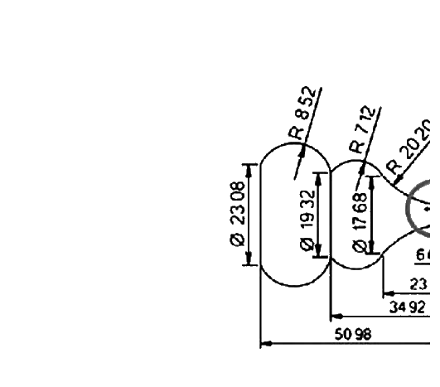 | Machining Objective  Combine several G02/G03 arcs to generate a decorative profile  Program Logic  The program uses Complex contour turning to generate the feature shown in the drawing. Review the start position, cutting direction, stock allowance, feed mode and safe retract before running the cycle.
Representative CNC Program
T0101
M03 S1000
G99
G0 X35.5 Z1
G71 U0.8 R0.4
G71 P1 Q2 U0.2 W0
N1 G0 X0
G1 Z0 F0.15
G03 ...
G02 ...
N2 X35.5
G70 P1 Q2
M30
Key Review Points
• Verify work zero, raw-stock size and chuck/jaw clearance.
• Confirm tool number, offset, insert geometry and spindle/feed mode.
• Check every rapid move and the final retract position.

CASE 07 | Constant Surface Speed Profile
G96 / G97
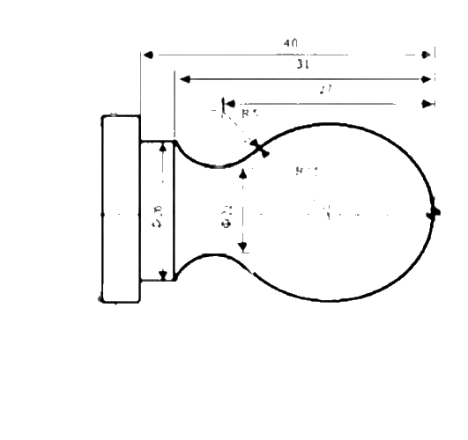 | Machining Objective  Use constant surface speed while the cutting diameter changes  Program Logic  The program uses G96 / G97 to generate the feature shown in the drawing. Review the start position, cutting direction, stock allowance, feed mode and safe retract before running the cycle.
Representative CNC Program
G92 X40 Z5
M03 S400
G96 S80
G00 X0
G01 Z0 F60
G03 U24 W-24 R15
G02 X26 Z-31 R5
G01 Z-40
X40 Z5
G97 S300
M30
Key Review Points
• Verify work zero, raw-stock size and chuck/jaw clearance.
• Confirm tool number, offset, insert geometry and spindle/feed mode.
• Check every rapid move and the final retract position.

CASE 08 | G71 Tapered Profile
G71 + G70
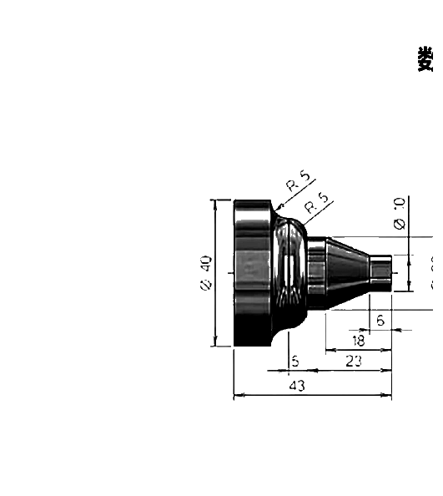 | Machining Objective  Rough and finish a tapered profile containing small radius transitions  Program Logic  The program uses G71 + G70 to generate the feature shown in the drawing. Review the start position, cutting direction, stock allowance, feed mode and safe retract before running the cycle.
Representative CNC Program
G99
T0101
G97 S600 M03
G0 X31 Z0
G71 U1.5 R0.5
G71 P1 Q2 U0.5 W0.2 F0.2
N1 G0 X0
G3 X6 Z-3 R3 F0.1
G2 X12 Z-6 R3
G1 X20 Z-20
N2 X31
G70 P1 Q2
M30
Key Review Points
• Verify work zero, raw-stock size and chuck/jaw clearance.
• Confirm tool number, offset, insert geometry and spindle/feed mode.
• Check every rapid move and the final retract position.
• Confirm P/Q contour validity and finishing allowance on the actual controller.

CASE 09 | Concave / Convex Arc Turning
G02 / G03
Machining Objective
Practice clockwise and counterclockwise circular interpolation in the lathe X-Z plane
Program Logic
The program uses G02 / G03 to generate the feature shown in the drawing. Review the start position, cutting direction, stock allowance, feed mode and safe retract before running the cycle.
Representative CNC Program
T0101
M03 S1000
G99
G0 X28 Z1
G01 X30 Z0 F0.15
G03 X40 Z-5 R5
G01 Z-35
G02 X50 Z-40 R5
G0 X100 Z100
M30
Key Review Points
• Verify work zero, raw-stock size and chuck/jaw clearance.
• Confirm tool number, offset, insert geometry and spindle/feed mode.
• Check every rapid move and the final retract position.

CASE 10 | Pulley Groove Profile
G75 + PROFILE MOVES
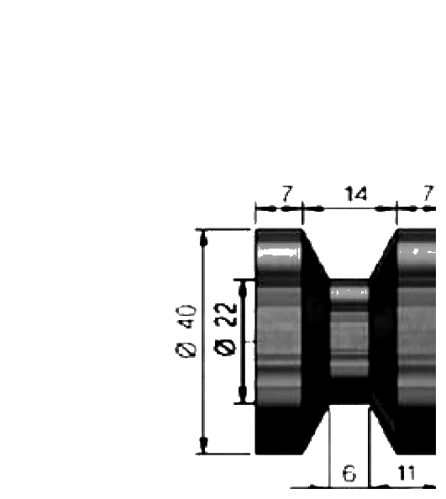 | Machining Objective  Machine a pulley-style groove using grooving and direct contour moves  Program Logic  The program uses G75 + profile moves to generate the feature shown in the drawing. Review the start position, cutting direction, stock allowance, feed mode and safe retract before running the cycle.
Representative CNC Program
T0101
M03 S800
G99
G0 X41 Z-15
G75 R0.6
G75 X22 Z-17 P2 Q3.50 F0.1
G0 X42 Z-21
G1 X40 F0.1
X22 Z-15
Z-17
G0 X100 Z100
M30
Key Review Points
• Verify work zero, raw-stock size and chuck/jaw clearance.
• Confirm tool number, offset, insert geometry and spindle/feed mode.
• Check every rapid move and the final retract position.

CASE 11 | G90 vs. G91 Coordinate Modes
COORDINATE PROGRAMMING
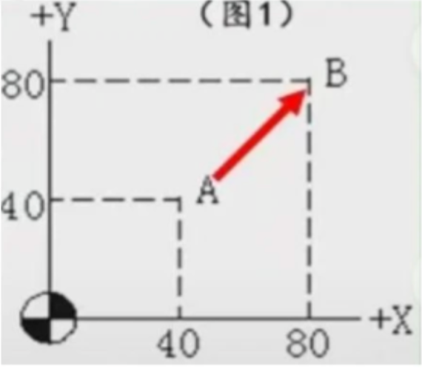 | Machining Objective  Understand absolute and incremental coordinate programming  Program Logic  The program uses Coordinate programming to generate the feature shown in the drawing. Review the start position, cutting direction, stock allowance, feed mode and safe retract before running the cycle.
Representative CNC Program
G90 X80 Y80
G91 X40 Y40
G90 X40 Y40
G91 X-40 Y-40
Key Review Points
• Verify work zero, raw-stock size and chuck/jaw clearance.
• Confirm tool number, offset, insert geometry and spindle/feed mode.
• Check every rapid move and the final retract position.

CASE 12 | G02 Radius Profile
G02 ARC PROGRAMMING
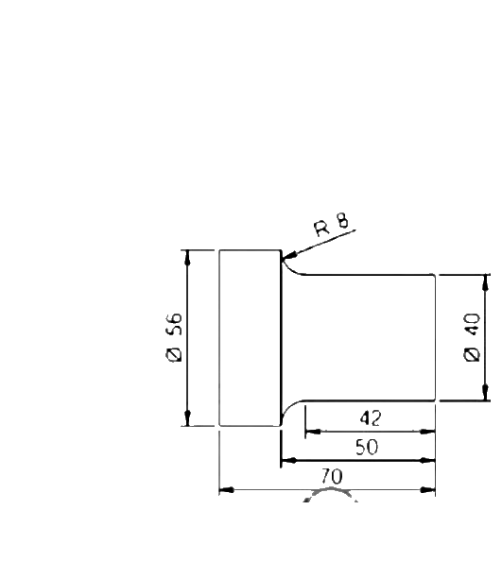 | Machining Objective  Turn an external R8 transition and finish the contour  Program Logic  The program uses G02 arc programming to generate the feature shown in the drawing. Review the start position, cutting direction, stock allowance, feed mode and safe retract before running the cycle.
Representative CNC Program
T0101
M03 S1000
G0 X58 Z1
G71 U1 R0.4
G71 P1 Q2 U0.4 W0.1 F0.3
N1 G0 X40
G01 Z-42 F0.15
N2 G02 X56 Z-50 R8 F0.15
G70 P1 Q2
M30
Key Review Points
• Verify work zero, raw-stock size and chuck/jaw clearance.
• Confirm tool number, offset, insert geometry and spindle/feed mode.
• Check every rapid move and the final retract position.

CASE 13 | Live-Tool Hex Milling
C-AXIS LIVE TOOLING
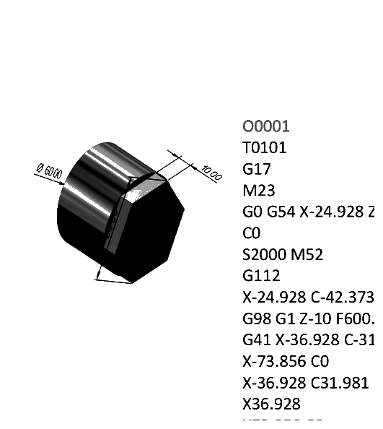 | Machining Objective  Machine six flats with a driven tool and C-axis interpolation/indexing  Program Logic  The program uses C-axis live tooling to generate the feature shown in the drawing. Review the start position, cutting direction, stock allowance, feed mode and safe retract before running the cycle.
Representative CNC Program
T0101
G17
M23
G0 G54 X24.928 Z25
C0
S2000 M52
G112
... indexed milling moves ...
G40 X-60.928
G0 Z25
G113
M55
M30
Key Review Points
• Verify work zero, raw-stock size and chuck/jaw clearance.
• Confirm tool number, offset, insert geometry and spindle/feed mode.
• Check every rapid move and the final retract position.
• Machine-builder M-codes and C-axis interlocks must be verified on the actual turning center.

CASE 14 | Face Drilling with C-Axis
LIVE-TOOL DRILLING
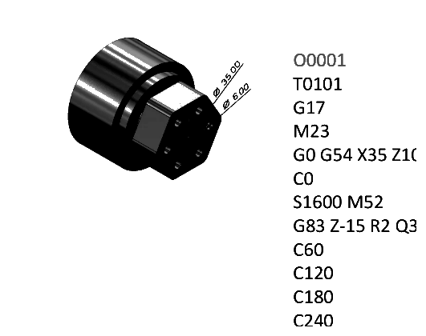 | Machining Objective  Drill an indexed bolt-hole pattern on the end face  Program Logic  The program uses Live-tool drilling to generate the feature shown in the drawing. Review the start position, cutting direction, stock allowance, feed mode and safe retract before running the cycle.
Representative CNC Program
T0101
G17
M23
G0 G54 X35 Z10
C0
S1600 M52
G83 Z-15 R2 Q3 F120
C60
C120
C180
C240
C300
G80
M55
M30
Key Review Points
• Verify work zero, raw-stock size and chuck/jaw clearance.
• Confirm tool number, offset, insert geometry and spindle/feed mode.
• Check every rapid move and the final retract position.
• Machine-builder M-codes and C-axis interlocks must be verified on the actual turning center.

CASE 15 | G73 Profile Roughing
G73 PATTERN REPEATING
Machining Objective
Rough a near-net-shape blank by repeating offset versions of the final contour
Program Logic
The program uses G73 pattern repeating to generate the feature shown in the drawing. Review the start position, cutting direction, stock allowance, feed mode and safe retract before running the cycle.
Representative CNC Program
M03 S600
T0101
G0 X87 Z2
G73 U4 W4 R14
G73 P1 Q2 U0.5 W0.5 F0.2
N1 G0 X20
G01 Z-5
G03 X30 Z-5 R5
...
N2 X87
G0 X150 Z150
M30
Key Review Points
• Verify work zero, raw-stock size and chuck/jaw clearance.
• Confirm tool number, offset, insert geometry and spindle/feed mode.
• Check every rapid move and the final retract position.
• Confirm P/Q contour validity and finishing allowance on the actual controller.

CASE 16 | G72 Facing Roughing
G72 FACING CYCLE
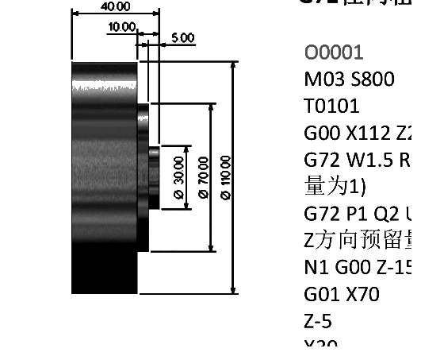 | Machining Objective  Remove stock primarily in the facing direction  Program Logic  The program uses G72 facing cycle to generate the feature shown in the drawing. Review the start position, cutting direction, stock allowance, feed mode and safe retract before running the cycle.
Representative CNC Program
T0101
S800 M03
G0 X112 Z2
G72 W1.5 R1 F0.2
G72 P1 Q2 U0.5 W0.5
N1 G00 Z-15
G01 X70
Z-5
X30
Z1
N2 X112
G0 X150 Z150
M30
Key Review Points
• Verify work zero, raw-stock size and chuck/jaw clearance.
• Confirm tool number, offset, insert geometry and spindle/feed mode.
• Check every rapid move and the final retract position.
• Confirm P/Q contour validity and finishing allowance on the actual controller.

CASE 17 | G74 End-Face Grooving
G74 GROOVING
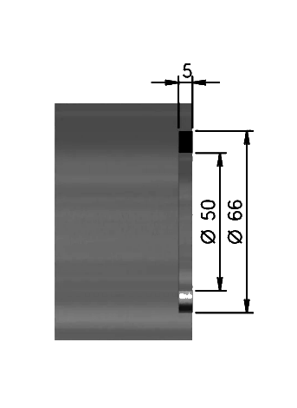 | Machining Objective  Cut an end-face groove with repeated controlled infeed  Program Logic  The program uses G74 grooving to generate the feature shown in the drawing. Review the start position, cutting direction, stock allowance, feed mode and safe retract before running the cycle.
Representative CNC Program
T0101
S800 M03
G0 X57.5 Z2
G74 R0
G74 X50 Z-4.8 P3.5 Q0 F0.15
G0 Z2
X150
Z150
M05
M30
Key Review Points
• Verify work zero, raw-stock size and chuck/jaw clearance.
• Confirm tool number, offset, insert geometry and spindle/feed mode.
• Check every rapid move and the final retract position.

CASE 18 | Indexed End-Face Drilling
C-AXIS DRILLING
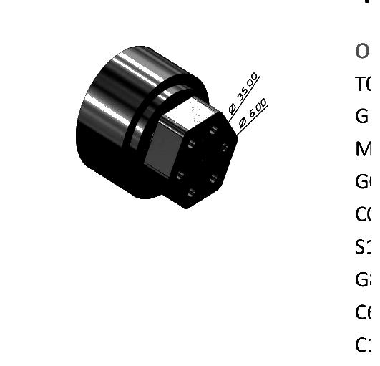 | Machining Objective  Repeat a drilling cycle at successive angular positions  Program Logic  The program uses C-axis drilling to generate the feature shown in the drawing. Review the start position, cutting direction, stock allowance, feed mode and safe retract before running the cycle.
Representative CNC Program
T0101
G17
M23
G0 G54 X35 Z10
C0
S1600 M52
G83 Z-15 R2 Q3 F120
C60
C120
C180
C240
C300
G80
M55
M30
Key Review Points
• Verify work zero, raw-stock size and chuck/jaw clearance.
• Confirm tool number, offset, insert geometry and spindle/feed mode.
• Check every rapid move and the final retract position.
• Machine-builder M-codes and C-axis interlocks must be verified on the actual turning center.

CASE 19 | G75 Radial Grooving
G75 GROOVING
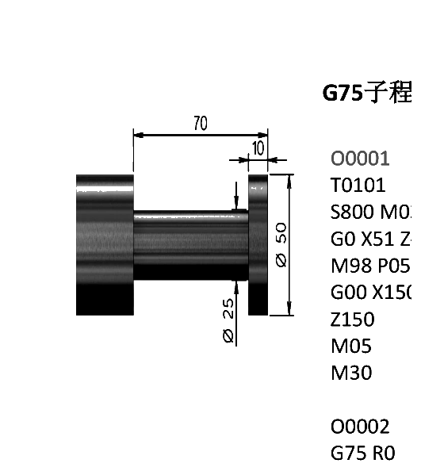 | Machining Objective  Machine a radial groove using pecking and axial stepping  Program Logic  The program uses G75 grooving to generate the feature shown in the drawing. Review the start position, cutting direction, stock allowance, feed mode and safe retract before running the cycle.
Representative CNC Program
T0101
S600 M03 G99
G0 X84 Z-21.5
G75 R3
G75 X60.5 Z-34.5 P3000 Q500 F0.15
G0 X84
Z-21
G1 X60 F0.1
Z-25
G0 X84
G0 X150 Z150
M30
Key Review Points
• Verify work zero, raw-stock size and chuck/jaw clearance.
• Confirm tool number, offset, insert geometry and spindle/feed mode.
• Check every rapid move and the final retract position.

CASE 20 | G76 Multi-Pass Threading
G76 THREADING
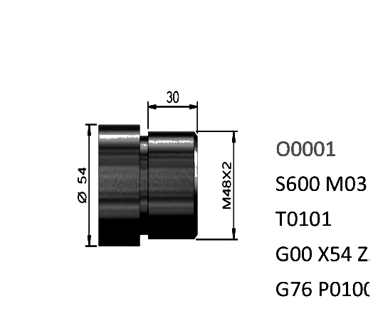 | Machining Objective  Cut a thread using a two-block multi-pass threading cycle  Program Logic  The program uses G76 threading to generate the feature shown in the drawing. Review the start position, cutting direction, stock allowance, feed mode and safe retract before running the cycle.
Representative CNC Program
S600 M03 G99
T0101
G0 X54 Z2
G76 P010060 Q100 R100
G76 X45.4 Z-32 P1300 Q500 R0 F2
G0 X150
Z150
M05
M30
Key Review Points
• Verify work zero, raw-stock size and chuck/jaw clearance.
• Confirm tool number, offset, insert geometry and spindle/feed mode.
• Check every rapid move and the final retract position.
• Confirm thread pitch, final diameter, infeed depth and run-out clearance.

Program Prove-Out Checklist
• Work zero and Z-face reference verified
• Raw-stock diameter and stick-out match the program
• Chuck and jaw envelope checked against all Z positions
• Tool numbers, offsets and insert orientation confirmed
• Spindle direction, speed mode and speed limit confirmed
• Feed mode and programmed feeds confirmed
• Thread pitch, groove width and drilling depth independently checked
• Rapid moves reviewed for collision risk
• Dry run completed with reduced rapid override
• First part inspected before continuous production
Important: These programs are training examples derived from the supplied case material. CNC cycle formats, M-codes, compensation behavior and safety requirements vary by controller and machine builder. Validate every program on the specific machine before production.

